Class Number_________________ Classification __________
UDC _________________ No.___________________

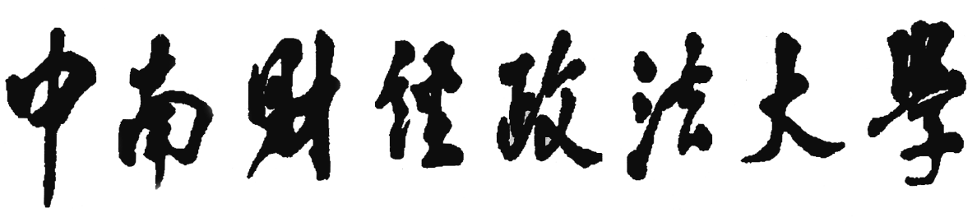
Doctoral Dissertation

Title of the Dissertation
Name of the postgraduate | :
Name and title of the supervisor | :
Type of Applicant | : | Foreign Graduate Student
Learning Mode | : | Full time
Discipline | : | Law
Name of the specialty | :
Research concentration | :
Enrollment time | :

Date

Title Time New Roman 12 Bold

By

NAME

DATE

Dissertation submitted to Zhongnan University of Economics and Law in partial
fulfillment of the requirements for the degree of Doctor of Law

STATEMENT ON ORIGINALITY OF DISSERTATION
The dissertation submitted by me is the result of independent research under the guidance of my supervisor. Except for the quoted content, this dissertation does not contain any published or written works by other individuals or groups. Individuals and groups who have made important contributions to the research of this dissertation have been indicated in this dissertation.
The legal consequences of this statement will be borne by me.
Author of the dissertation (signature):
Date:

STATEMENT ON THE AUTHORIZATION FOR USE

The author of this dissertation fully understands the management measures and regulations of the university on the preservation and use of dissertations. Namely, the university has the right to keep and send copies and electronic versions of the dissertations to the relevant departments or institutions of the country, and allow the dissertations to be consulted and borrowed. I authorize Zhongnan University of Economics and Law to compile all or part of this dissertation into the relevant database, and the university can also save or compile this dissertation by photocopying, reducing or scanning.

Author of the dissertation (signature):
Date:

摘要

关键词：

ABSTRACT

Keywords:

ACKNOWLEDGEMENT

ABBREVIATIONS

TABLE OF CONTENTS

